# **Lab 2 - OpenStack Multi-Tenants Guide**

This guide explains in detail how to achieve all objectives of the lab using OpenStack, including screenshots and step-by-step instructions.

## **Objective 1: OpenStack Overview and Basic Networking**

Before starting, here are a couple of Openstack terminologies.

**Nova**

Nova manages and provisions compute resources. It is responsible for launching and managing virtual machines and also handles scheduling, lifecycle management, and scaling of VMs.

**Swift**

Swift provides scalable, redundant, and distributed object storage. It stores unstructured data like files, backups, images, and media. It uses a replication mechanism to ensure data redundancy and availability.

**Cinder**

Cinder provides block-level storage for virtual machines. It allows users to create and attach volumes to instances. It also allows users to take volume snapshots and backups.

**Neutron**

Neutron manages the networking stuff of OpenStack. It helps in creation of virtual networks, subnets, and routers. It also supports features like firewalls, load balancing, and VPNs and integrates SDN solutions.

**Glance**

Glance provides a service for discovering, registering, and retrieving virtual machine images. It allows users to upload custom images or use pre-configured images and integrates well with other components of OpenStack to launch instances.

**Keystone**

Keystone handles authentication and authorization for OpenStack services. It acts as the central identity management system, ensuring secure access control across OpenStack. It manages user accounts, roles, and access policies and provides token-based authentication for secure interactions.

**Horizon**

Horizon is a component in OpenStack that provides a web-based graphical user interface reducing the reliance on CLI commands. It helps in managing storage, compute and networking resources and simplifies resource provisioning and monitoring.

**Users & Roles**

A **user** represents an individual account that interacts with OpenStack. A user has credentials to authenticate and can be associated with one or more projects/tenants.

A **role** is a set of permissions or access rights that define what actions a user can perform within a specific project or domain. A single user can have multiple roles, and roles can differ across projects.

**Hypervisors**

A **hypervisor** is a layer of software, firmware, or hardware that allows multiple VMs to run on a single physical machine (virtualization) by abstracting and allocating the underlying physical hardware resources, such as CPU, memory, network resources, etc. Each VM operates as if it has its own dedicated hardware.

In OpenStack, hypervisors are managed by Nova. OpenStack supports various hypervisors such as KVM, QEMU, VMware vSphere/ESXi, Hyper-V, etc.

**Flavor**

In OpenStack, a flavor is a preset configuration that defines the compute, memory, and storage capacity of an instance or a VM. It allows users to specify the size and capacity of the resources required for their VMs when they are launched. For example, OpenStack provides default flavors such as m1.small or m1.large, however, admins can create custom flavors tailored to specific workloads.

### **Create a Network with 64 IP Addresses with DHCP enabled**

| openstack network create internal-network-1  openstack subnet create --network internal-network-1 \  --subnet-range 192.168.10.0/24 \  --dhcp --allocation-pool start=192.168.10.2,end=192.168.10.33 \  internal-network-1-subnet |
| --- |

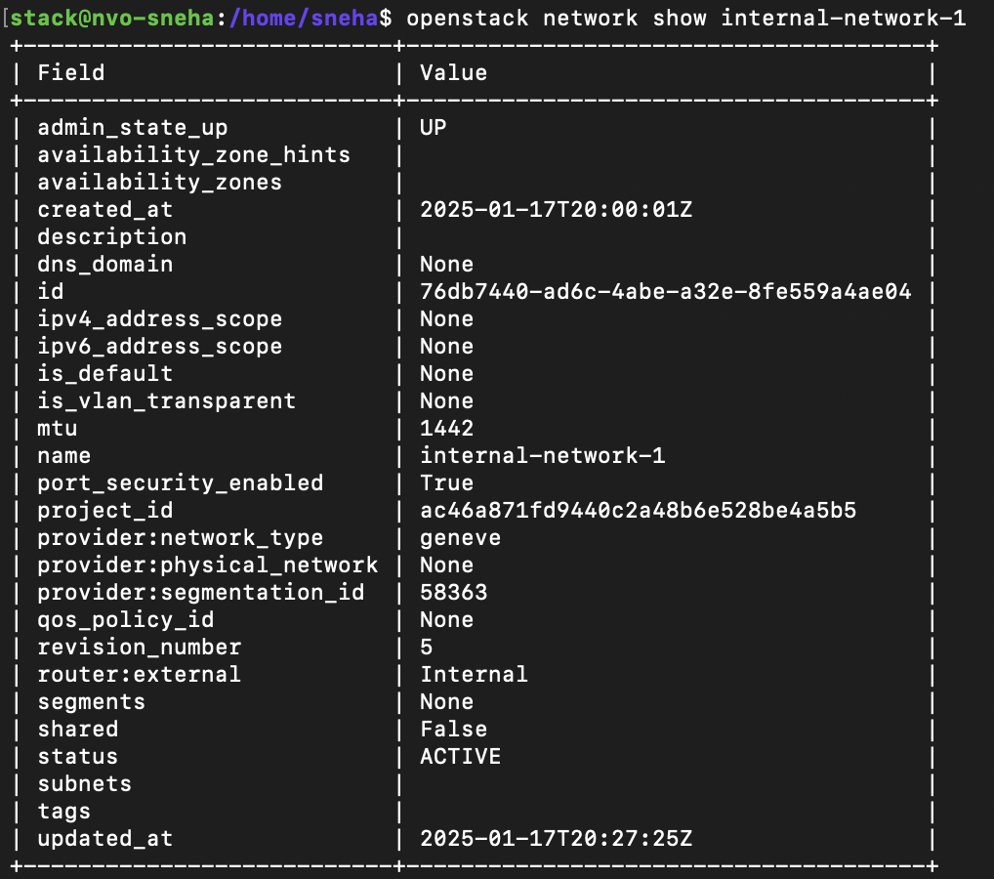

*Screenshot 1: Creating a network “internal-network-1”*

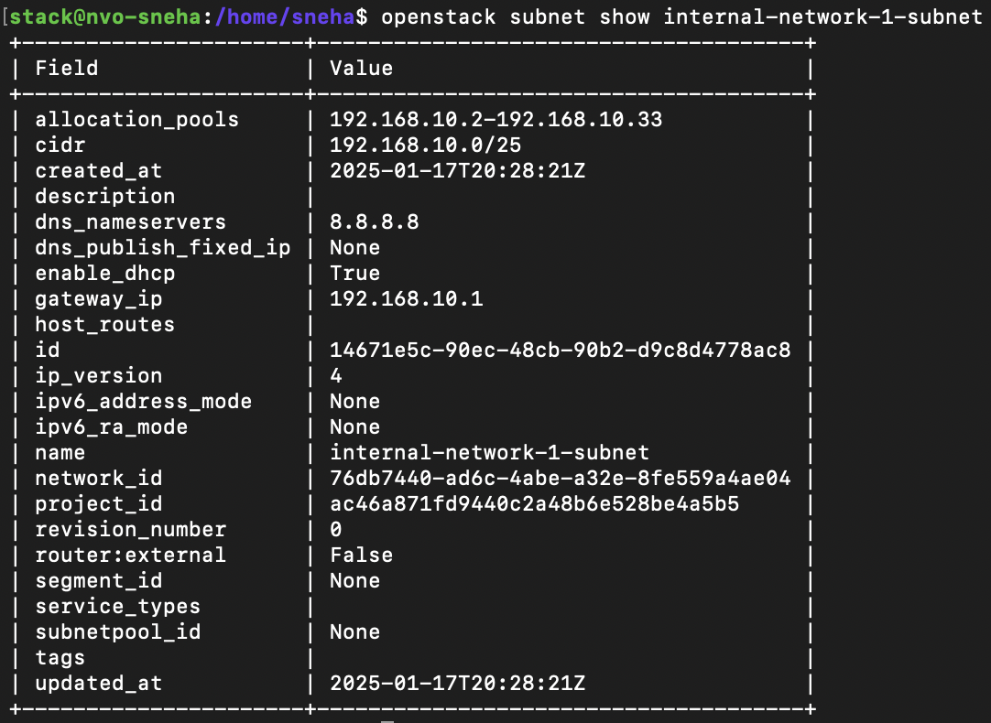

*Screenshot 2: Creating a subnet “internal_network_1_subnet” with 64 usable IP addresses, with 32 allocated for DHCP leasing.*

### **Create a Router and Connect the Network to the Public Network**

| openstack router create internal-network-1-router  openstack router set --external-gateway public internal-network-1-router  openstack router add subnet internal-network-1-router internal-network-1-subnet |
| --- |

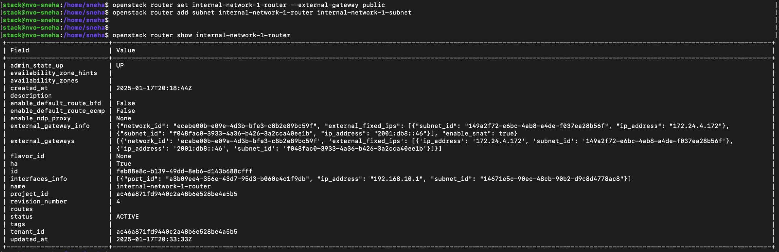*Screenshot 3: The router's internal interface IP is configured as the default gateway for internal-network-1-subnet, and the public network is set as the router's external gateway.*

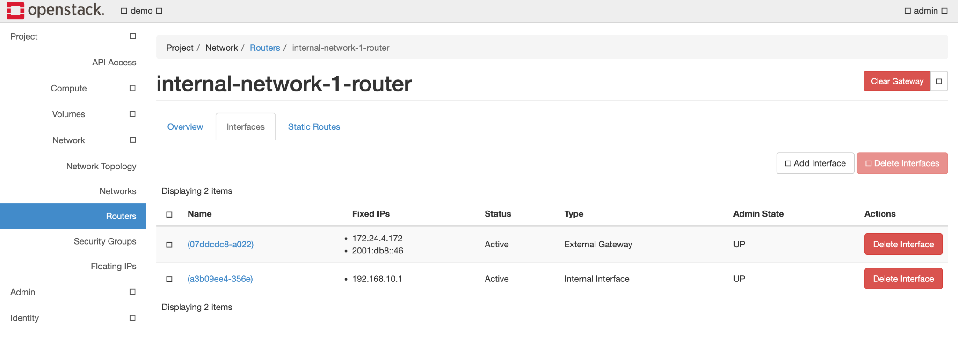

*Screenshot 4: The same configuration as Screenshot 3, displayed in the Horizon dashboard*

### **Launch Cirros Instances**

| openstack server create --flavor m1.tiny --image cirros-0.6.3-x86_64-disk --network internal-network-1 cirros-instance-1  openstack server create --flavor m1.tiny --image cirros-0.6.3-x86_64-disk --network internal-network-1 cirros-instance-2 |
| --- |



*Screenshot 5: Cirros server instances dynamically allocated IP address from internal-network-1-subnet*

### **Assign Floating IPs**

**Allocate a Floating IP**

* Go to **Project > Network > Floating IPs**.
* Click **Allocate IP to Project** and select the public

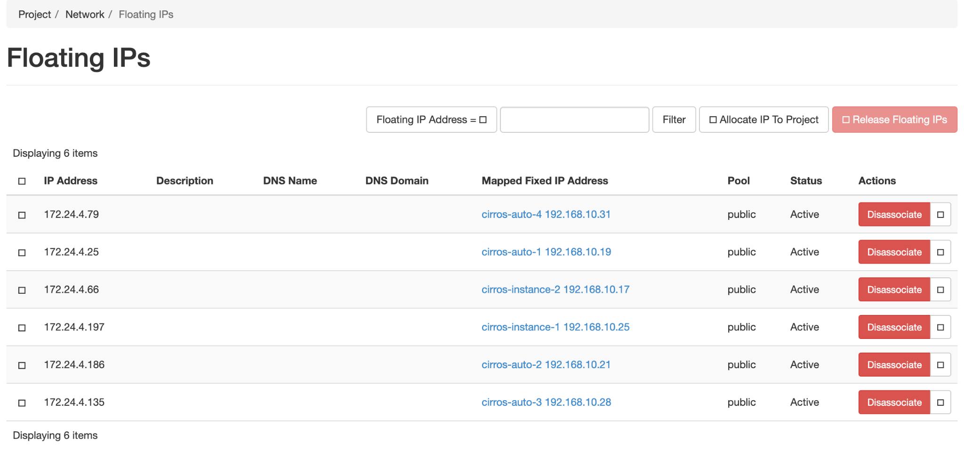

*Screenshot 6: Allocating floating IP*

**Associate Floating IP with an Instance**:

* Click **Associate** next to the allocated floating IP.
* Select cirros-instance-1 from the dropdown.



*Screenshot 7: Floating IP assigned to the instances*

## **Objective 2: Auto-Scaling with Python**

### **Python Script for Monitoring CPU Utilization**

[*[Link to the code]*](https://github.com/coflin/Network-Virtualization-and-Orchestration/blob/main/cpu_util.py)

I am using regular ssh, netmiko to extract CPU Utilization. Here’s how the output looks like:



*Screenshot 6: Output of cpu_util.py script that extracts CPU usage of the cirros instances*

I am utilizing the OpenStack Python module to create instances. To increase CPU load, I use the yes command, which continuously outputs the letter 'y' to the command line. My code also assigns a floating IP address to each Cirros instance, enabling internet accessibility and monitoring. A CPU utilization threshold of 30% has been set, and if any instance exceeds this threshold, the code automatically spawns a new Cirros instance. Once the total number of instances reaches 4, the code stops creating additional instances and exits as seen in the below screenshot.

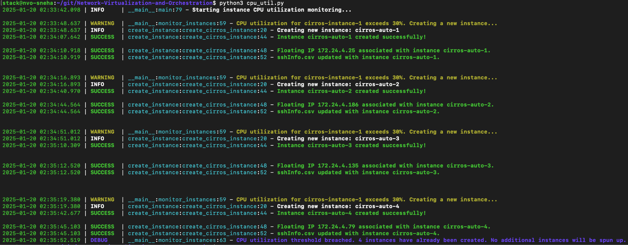

*Screenshot 8: Output of the cpu utilization code running and creating new instances on demand*

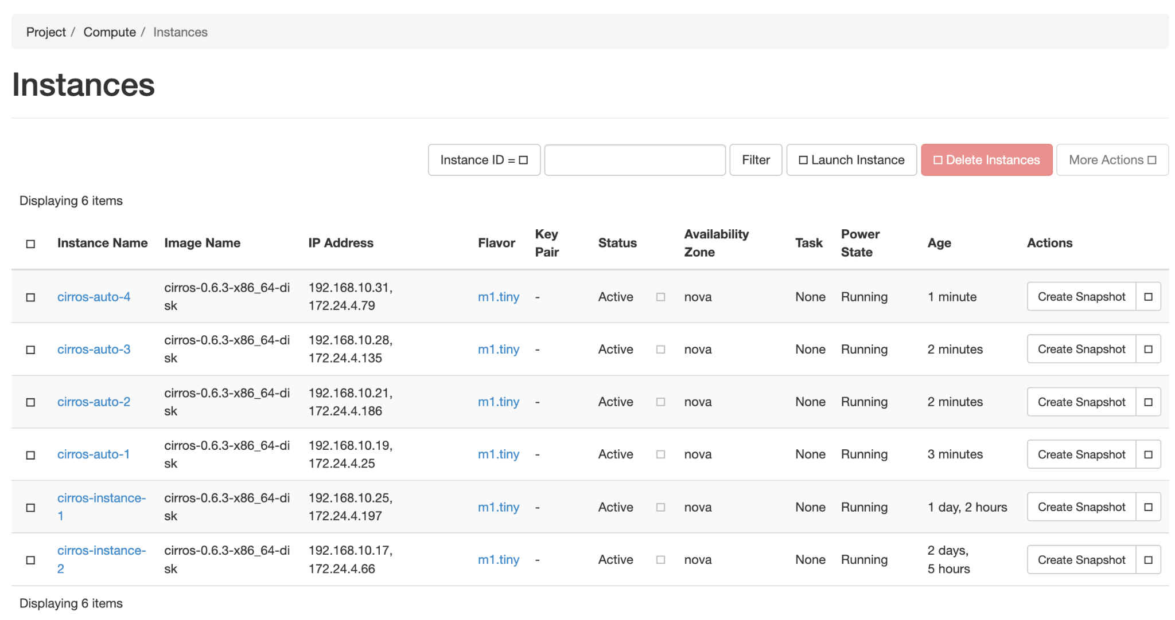

*Screenshot 9: Horizon dashboard displaying the instances created by the code*

## **Objective 3: Multi-Tenants**

### **Create a Project and User**:

* **Using Horizon**:
  + Go to **Identity > Projects** and click **Create Project**
  + Enter:
    - **Project Name**: lab2
    - **Description**: Optional
    - **Enabled**: Checked
  + Click **Create Project**.
  + Navigate to **Identity > Users** and click **Create User**.
  + Enter:
    - **Username**: lab2_admin
    - **Email**: Optional
    - **Password**: Set your password
    - **Primary Project**: lab2
    - **Role**: admin
  + Click **Create User**:



*Screenshot 10: Project lab2 created*



*Screenshot 11: User lab2_admin*

* **Create a Flavor**:
  + Navigate to **Admin > Flavors** and click **Create Flavor**.
  + Enter:
    - **Flavor Name**: ngn.tiny
    - **vCPUs**: 1
    - **RAM**: 128 MB
    - **Root Disk**: 1 GB
    - **Ephemeral Disk**: 1 GB
    - **Swap Disk**: 1 GB
  + Click **Create Flavor**.
* **Upload an Image**:
  + Go to **Admin > Images** and click **Create Image**.
  + Enter:
    - **Image Name**: tinycore
    - **Image Source**: [link](http://tinycorelinux.net/7.x/x86/release/Core-current.iso)
    - **Format**: ISO
    - **Visibility**: Public
  + Click **Create Image**



*Screenshot 12: Created ngn.tiny flavor*

### **Setup Virtual Networks**

1. **Create VN-A/VN-B**

| openstack network create VN-A  openstack subnet create --network VN-A --subnet-range 192.168.100.0/24 VN-A-Subnet  openstack network create VN-B  openstack subnet create --network VN-B --subnet-range 192.168.200.0/24 VN-B-Subnet |
| --- |

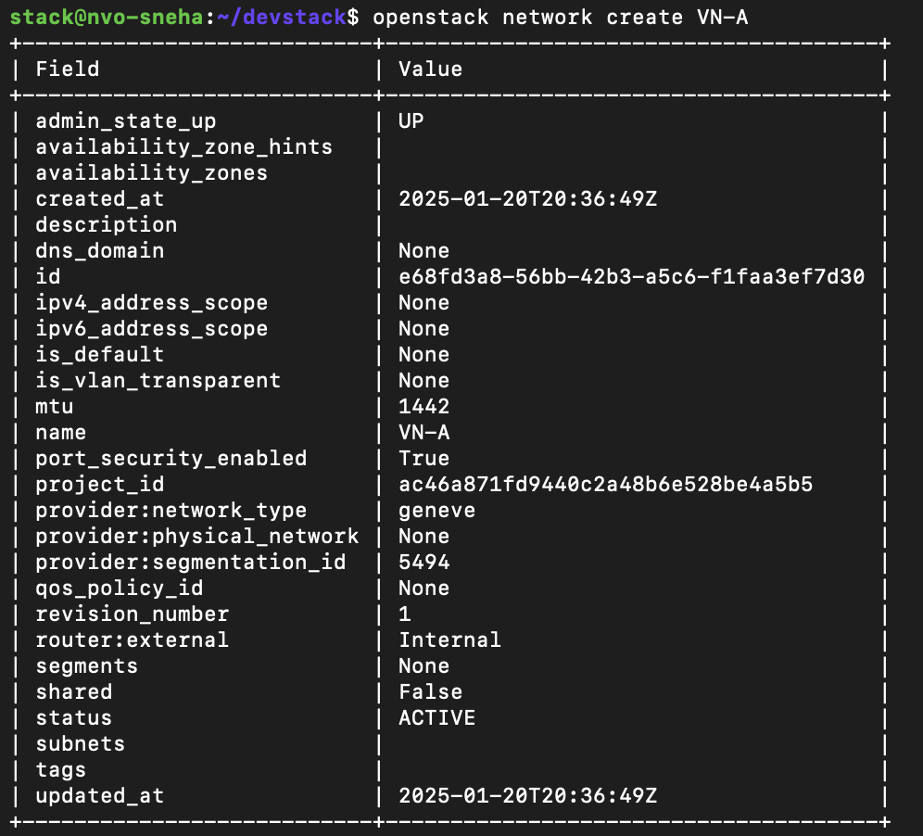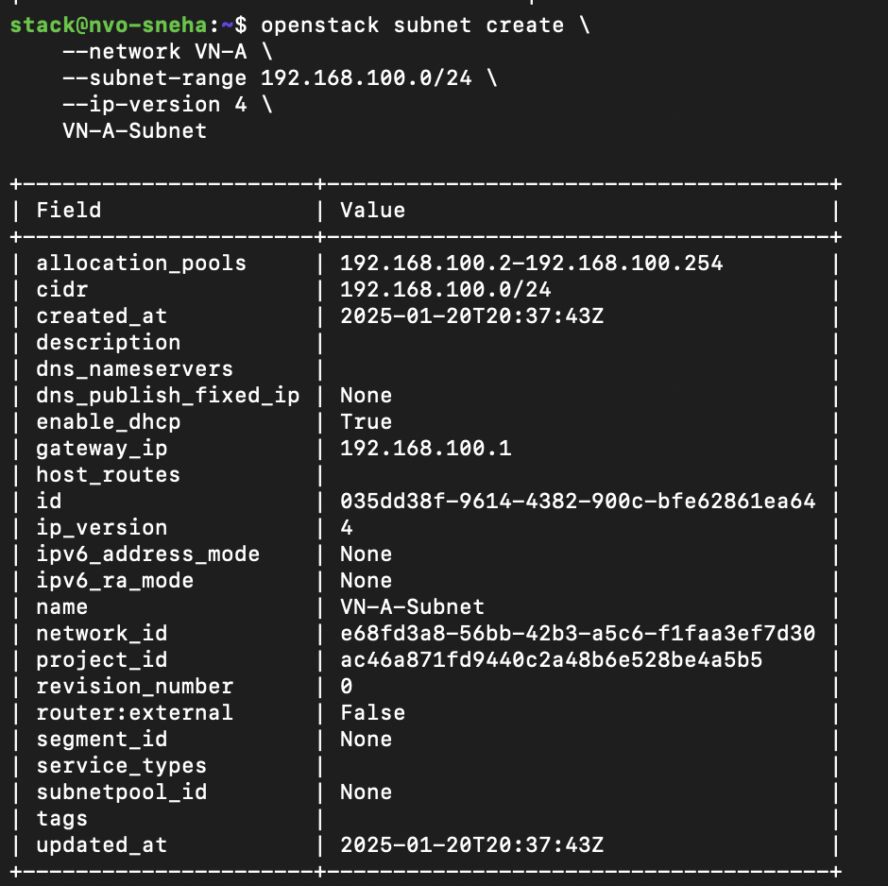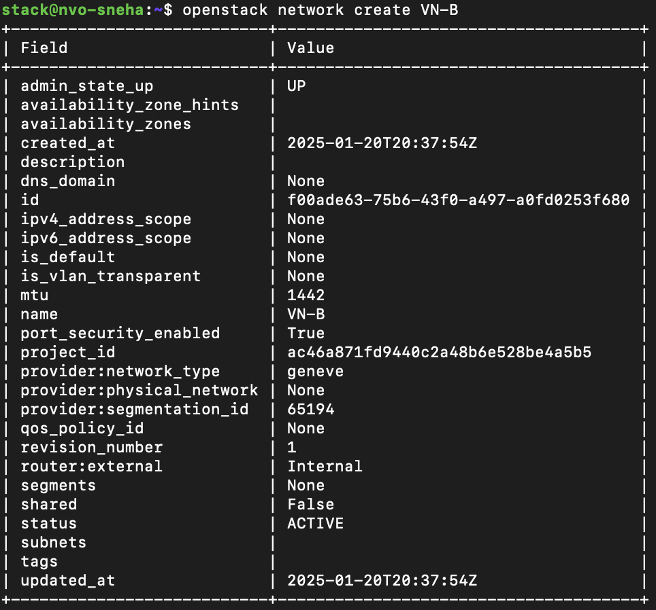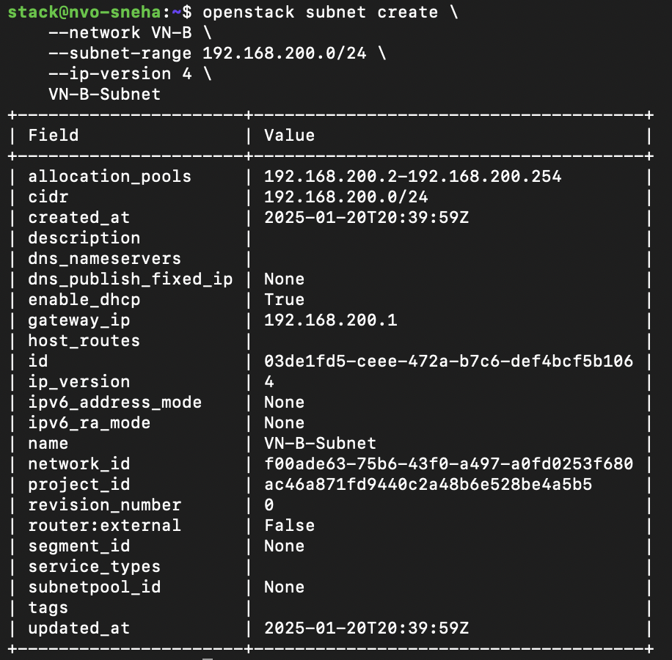

*Screenshot 13: Creating the VN-{A,B} networks and subnets*

#### 

### **Launch VM Instances**

**Launch VN-A_VM-1 and VN-A_VM-2 into VN-A**

| openstack server create --flavor ngn.tiny --image tinycore --network VN-A VN-A_VM-1  openstack server create --flavor ngn.tiny --image tinycore --network VN-A VN-A_VM-2 |
| --- |

**Launch VN-B_VM-1 into VN-B**

| openstack server create --flavor ngn.tiny --image tinycore --network VN-B VN-B_VM-1 |
| --- |

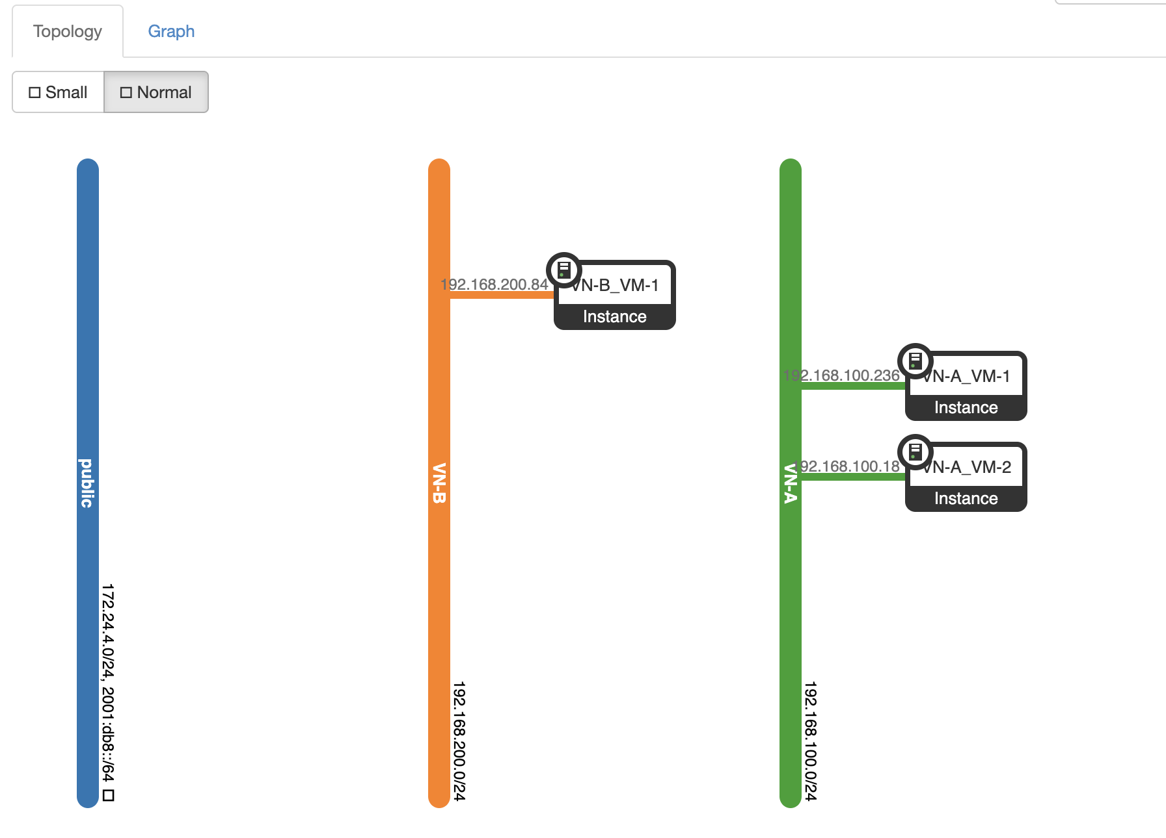

*Screenshot 14: Network topology after spinning up 2 VMs in VN-A and 1 VM in VN-B*

### **Ping testing**

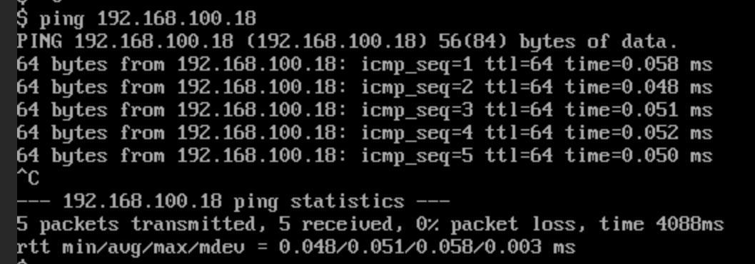

*Screenshot 15: Ping within the same Virtual Networks*

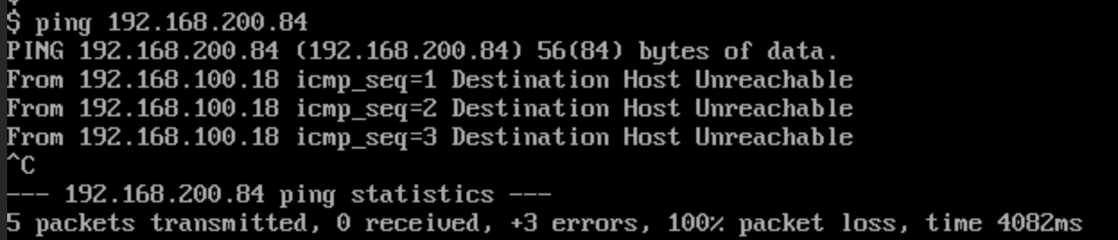

*Screenshot 16: Pinging from VN-A to VN-B*

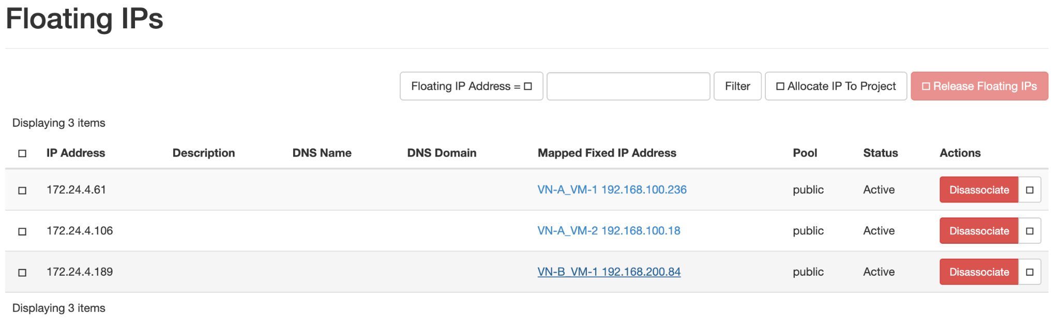

*Screenshot 17: Assigned floating IP addresses on all the VMs*

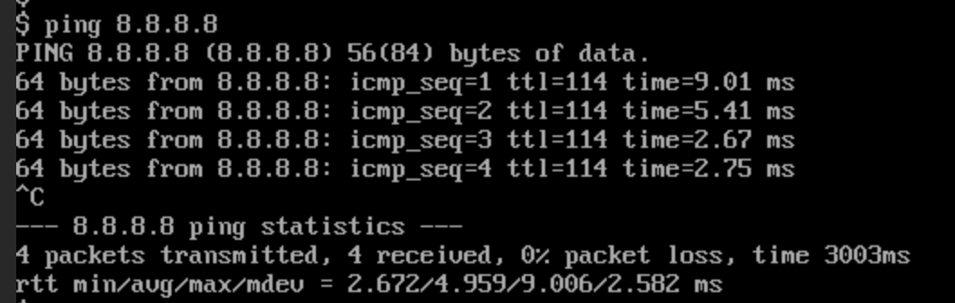

*Screenshot 18: Pinging the internet*

## 

## **Objective 4: Network Policy Management**

In the previous steps, we achieved internet connectivity between the VMs. I added a router that connects to the public network as well as the virtual networks to enable routing. Post adding the router, I was able to ping from VN-A to VN-B.

Here’s the network topology.

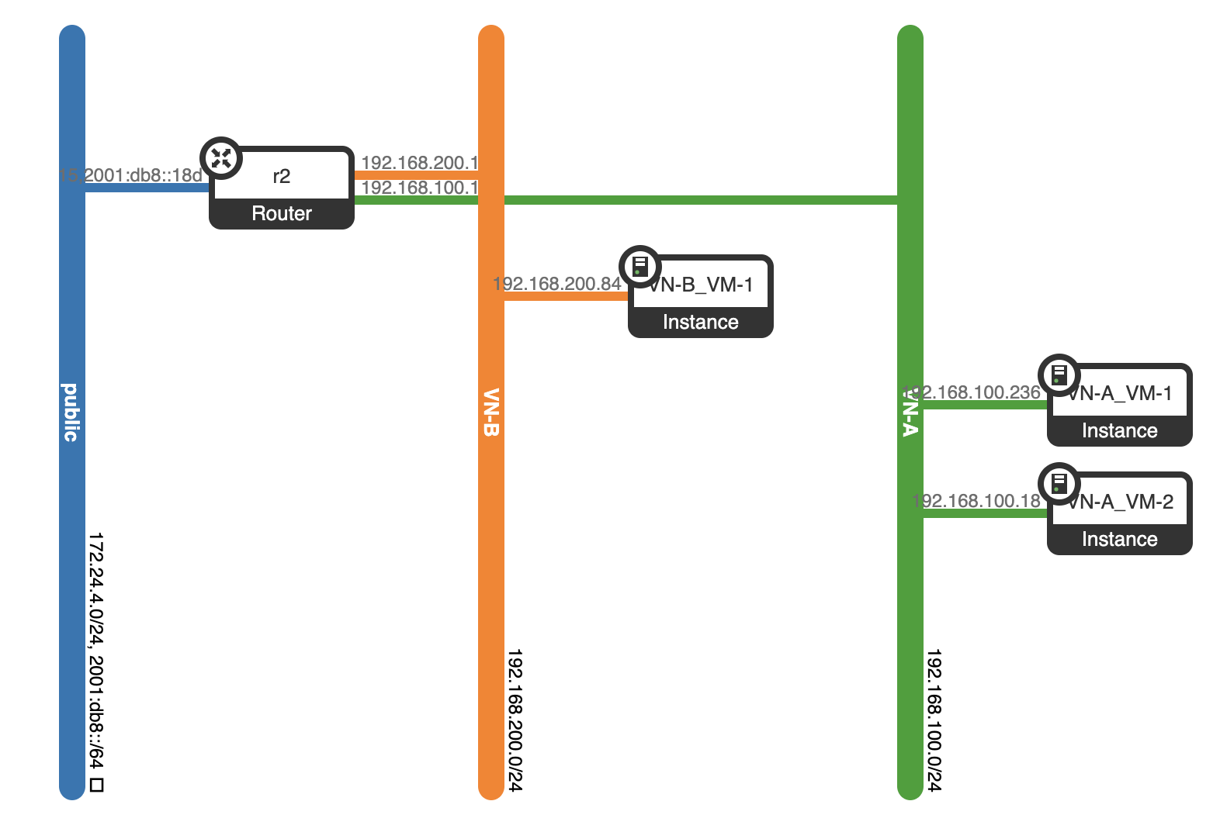

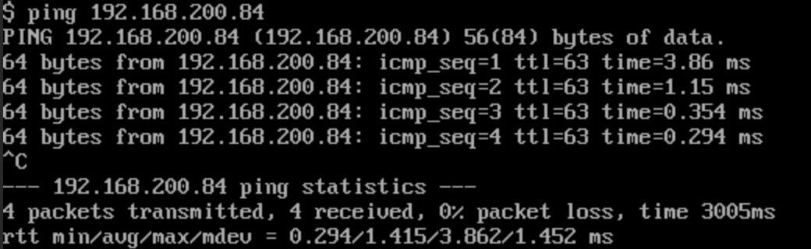

*Screenshot 19: Inter-VN communication from VN-A-VM_1 enabled after adding a router*

### **Configure Network Policies**

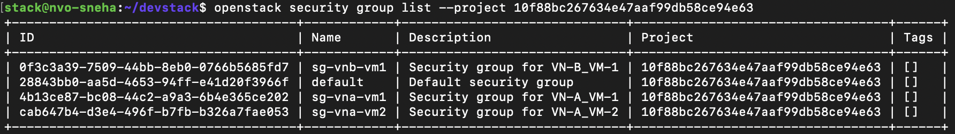

For each of the security groups, I created a custom rule.

**Case 1: VN-A_VM-1**

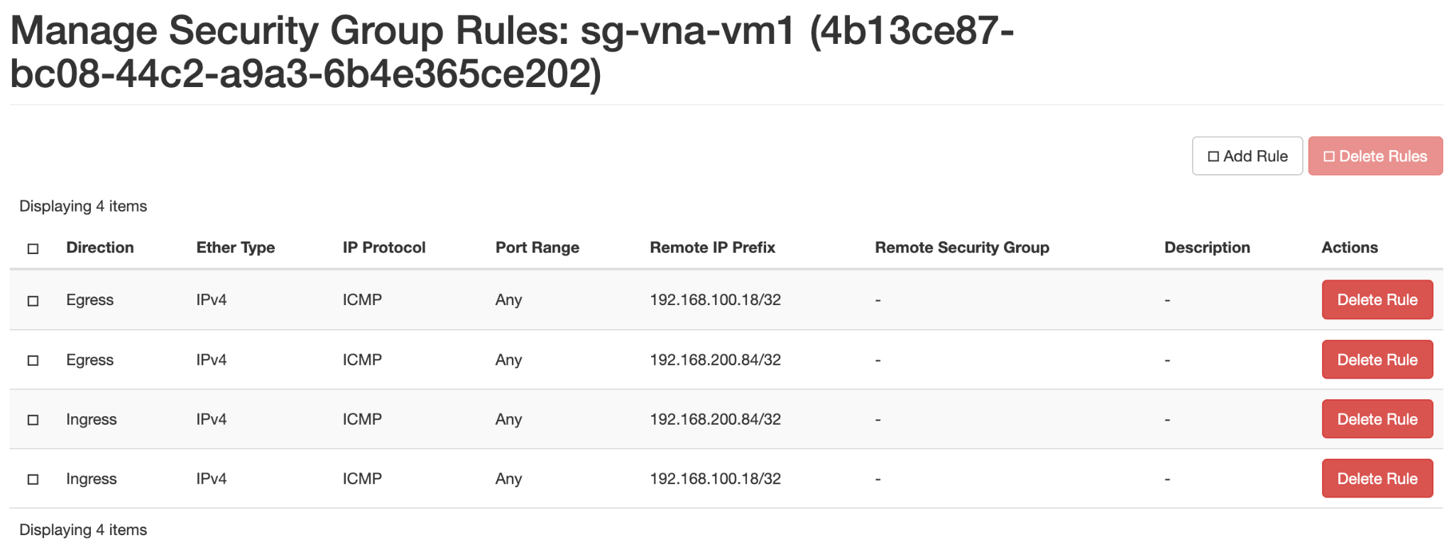

*Screenshot 20: Security group for VN-A_VM-1*

1. **Can ping VN-B_VM-1**

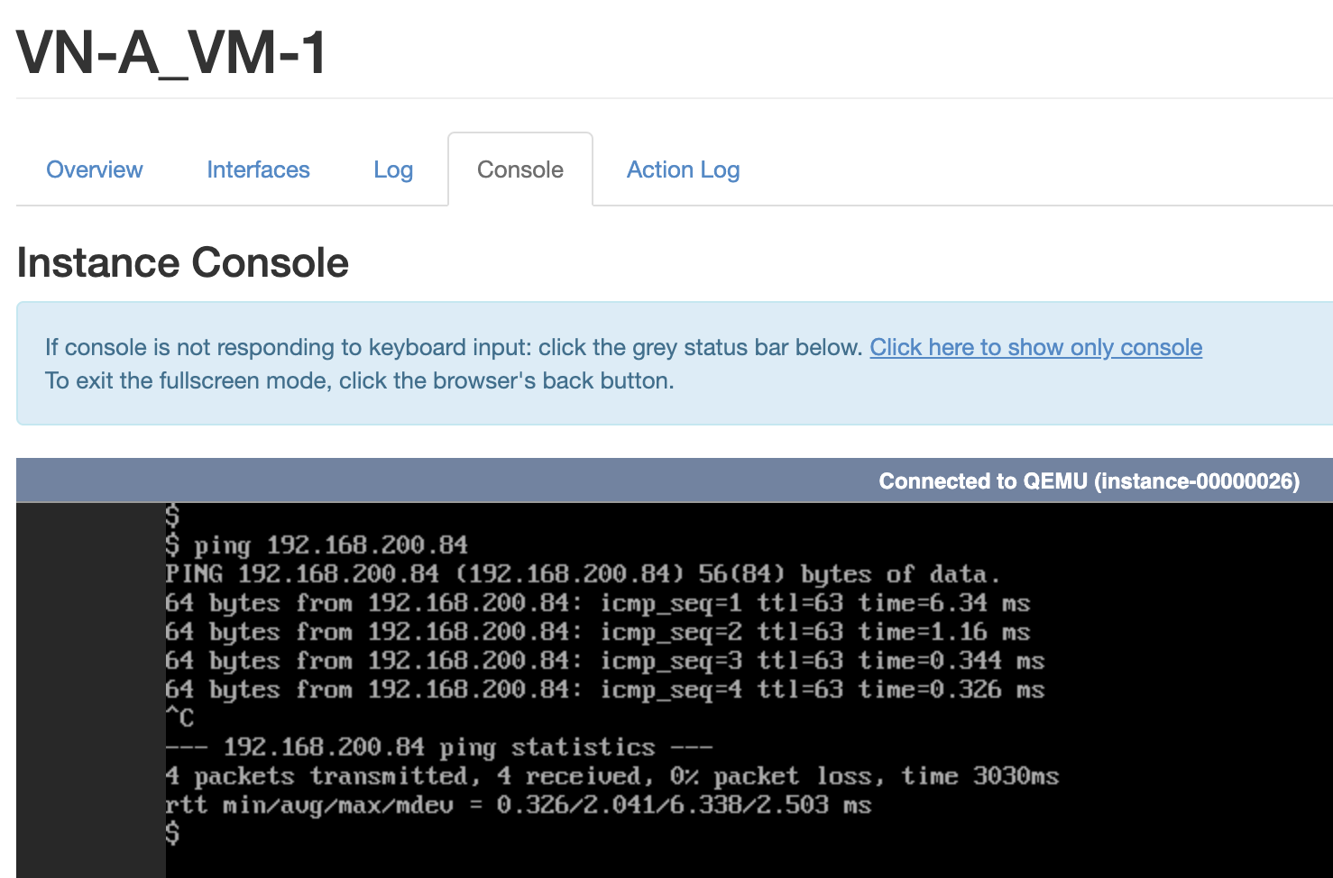

1. **Cannot ping the internet**

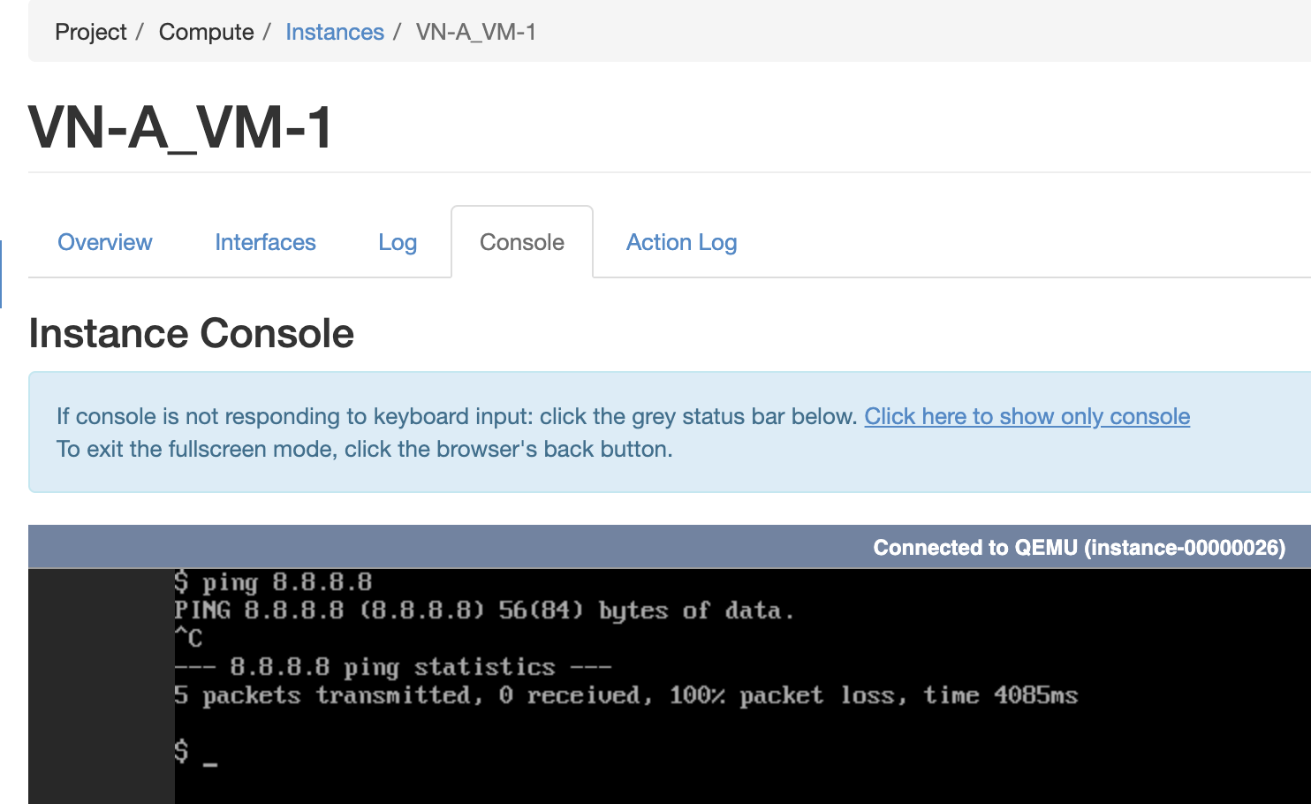

**Case 2: VN-A_VM-2**

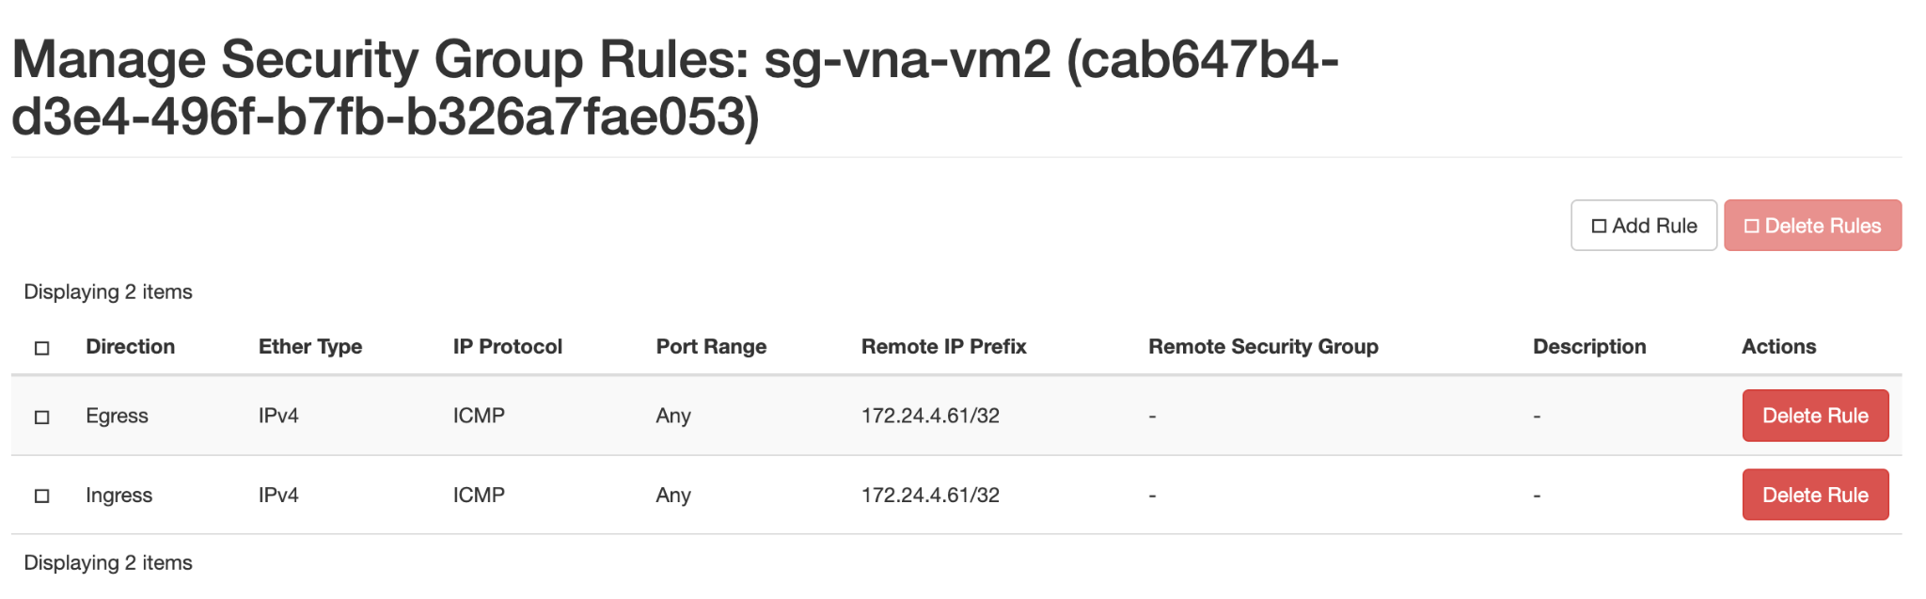

*Screenshot 21: Security group for VN-A_VM-2*

1. **Cannot ping VN-B_VM-1**

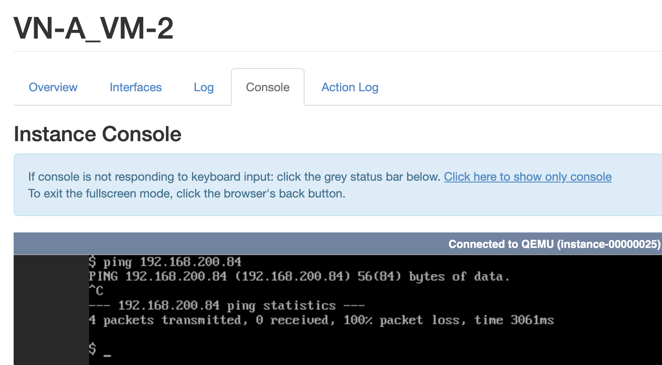

1. **Cannot ping the internet**

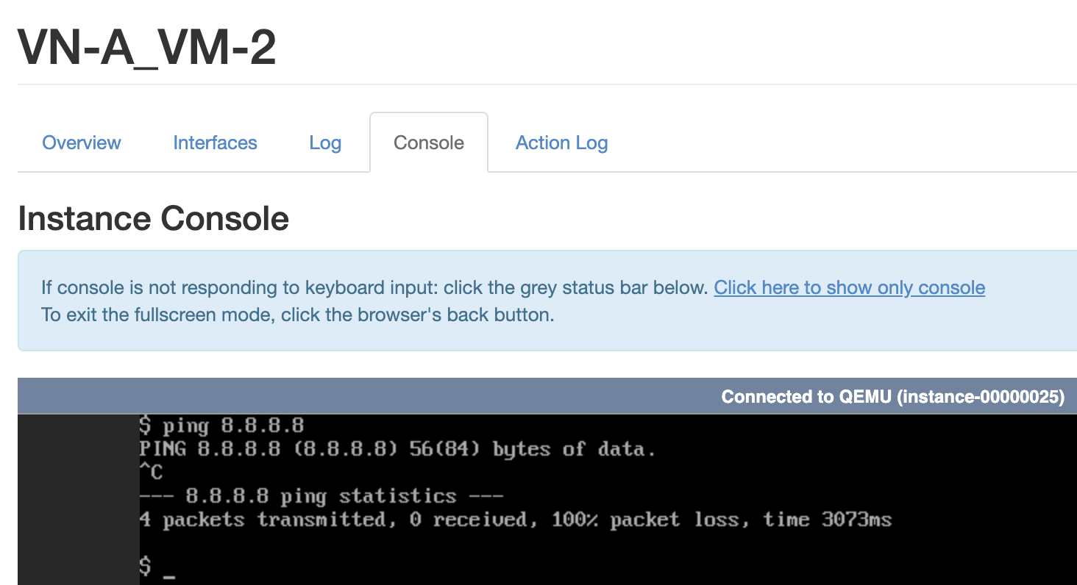

**Case 3: VN-B_VM-1**

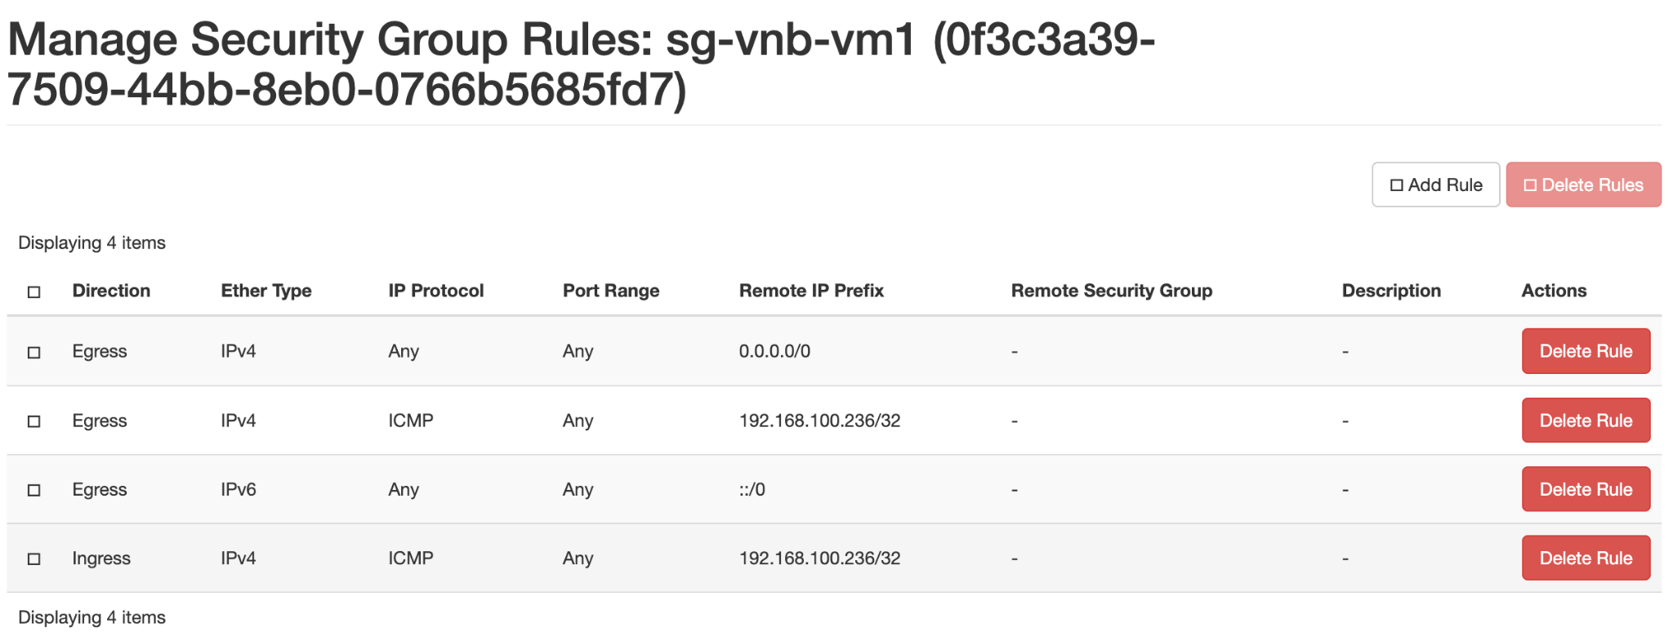

*Screenshot 22: Security group for VN-B_VM-1*

1. **Can ping VN-A_VM-1**

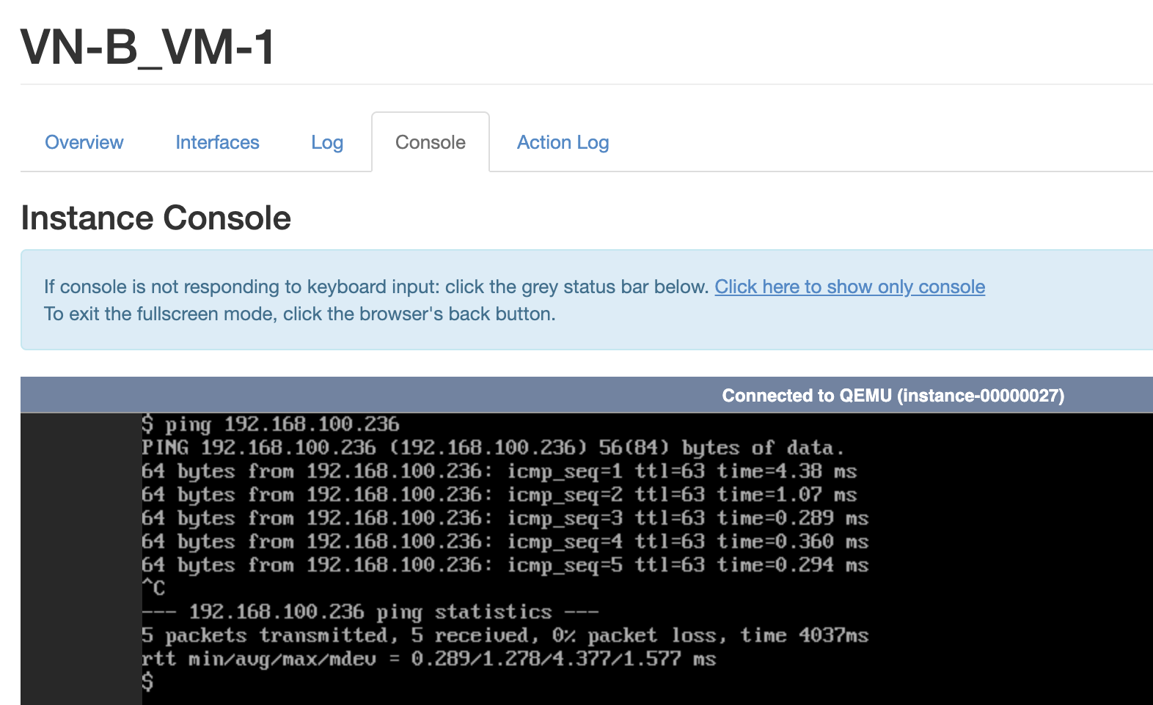

1. **Cannot ping VN-A_VM-2**

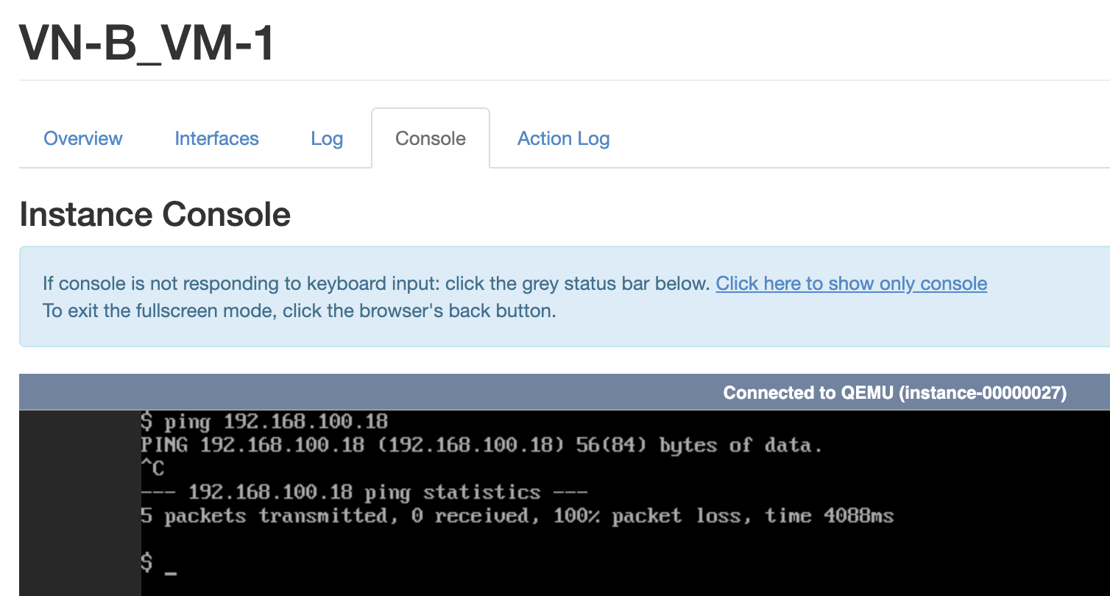

1. **Can ping the internet**

